Department of Artificial Intelligence and Data Science

Vision of the Department
To be a preferred hub for nurturing computer engineering aspirants through innovative, ethical, value-based technical education, impactful research, and industry collaboration, to become successful professionals contributing for the betterment of society.

Mission of the Department
To nurture computer engineering professionals by offering: Dynamic learning environment that encourages problem-solving using emerging technology, · National Education Policy aligned evidence-based technical education, fostering innovation, research, and industry–institute
collaboration, Holistic, ethical and sustainable development for lifelong success.

Session 2025-2026
Mission: Means to achieve vision
Vision: Dreams where you want
Program Educational Objectives of the program (PEO): (broad statements that describe the professional and career accomplishments)
PEO1 | Preparation | P: Preparation | Pep-CL abbreviation  pronounce as Pep-si-lL easy to recall
PEO2 | Core Competence | E: Environment (Learning Environment)
PEO3 | Breadth | P: Professionalism
PEO4 | Professionalism | C: Core Competence
PEO5 | Learning Environment | L: Breadth (Learning in diverse areas)

Program Outcomes (PO): (statements that describe what a student should be able to do and know by the end of a program)

Keywords of POs:
Engineering knowledge, Problem analysis, Design/development of solutions, Conduct Investigations of Complex Problems, Engineering Tool Usage, The Engineer and The World, Ethics, Individual and Collaborative Team work, Communication, Project Management and Finance, Life-Long Learning

PSO Keywords: Cutting edge technologies, Research

“I am an engineer, and I know how to apply engineering knowledge to investigate, analyse and design solutions to complex problems using tools for entire world following all ethics in a collaborative way with proper management skills throughout my life.” to contribute to the development of cutting-edge technologies and Research.

Integrity: I will adhere to the Laboratory Code of Conduct and ethics in its entirety.

Name and Signature of Student and Date
(Signature and Date in Handwritten)

Disha Angalwar

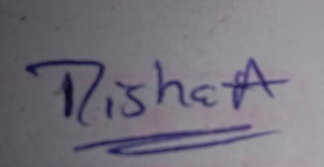

Department of Artificial Intelligence and Data Science

Vision of the Department
To be a preferred hub for nurturing computer engineering aspirants through innovative, ethical, value-based technical education, impactful research, and industry collaboration, to become successful professionals contributing for the betterment of society.

Mission of the Department
To nurture computer engineering professionals by offering: Dynamic learning environment that encourages problem-solving using emerging technology, · National Education Policy aligned evidence-based technical education, fostering innovation, research, and industry–institute
collaboration, Holistic, ethical and sustainable development for lifelong success.

Session | 2025-26 (EVEN) | Course Name | Java FSD Lab
Semester | IV | Course Code | 23ADS1407
Roll No | 04 | Name of Student | Disha Angalwar

Practical Number | 04
Course Outcome | - Develop backend applications using object-oriented programming concepts and implement data persistence using relational databases.  - Design and implement interactive and responsive user interfaces using standard web technologies.  - Build and integrate complete web applications by combining client-side and server-side components.
Aim | WAP to implement Searching ( linear search ) and Sorting (Bubble Sort ) in Java.
Problem Definition | WAP to implement  Searching  - linear search and  Sorting  - Bubble Sort and  - Insertion Sort in Java

Department of Artificial Intelligence and Data Science

Vision of the Department
To be a preferred hub for nurturing computer engineering aspirants through innovative, ethical, value-based technical education, impactful research, and industry collaboration, to become successful professionals contributing for the betterment of society.

Mission of the Department
To nurture computer engineering professionals by offering: Dynamic learning environment that encourages problem-solving using emerging technology, · National Education Policy aligned evidence-based technical education, fostering innovation, research, and industry–institute
collaboration, Holistic, ethical and sustainable development for lifelong success.

Theory  (100 words) | - Linear Search  - Linear Search checks each element of the array sequentially until the target element is found.  - It works on both sorted and unsorted arrays.  - It is simple and easy to implement using loops in Java.  - Its time complexity is O(n) in the worst case and O(1) in the best case.  - Bubble Sort  - Bubble Sort compares adjacent elements and swaps them if they are in the wrong order.  - After each pass, the largest element moves to its correct position.  - It requires multiple passes through the array.  - Its time complexity is O(n²), so it is not suitable for large datasets.  - Insertion Sort  - Insertion Sort builds the sorted array one element at a time.  - It places each element in its correct position among the sorted part.  - It is efficient for small or nearly sorted arrays.  - Its time complexity is O(n²) in the worst case and O(n) in the best case.

Department of Artificial Intelligence and Data Science

Vision of the Department
To be a preferred hub for nurturing computer engineering aspirants through innovative, ethical, value-based technical education, impactful research, and industry collaboration, to become successful professionals contributing for the betterment of society.

Mission of the Department
To nurture computer engineering professionals by offering: Dynamic learning environment that encourages problem-solving using emerging technology, · National Education Policy aligned evidence-based technical education, fostering innovation, research, and industry–institute
collaboration, Holistic, ethical and sustainable development for lifelong success.

Procedure and Execution

(100 Words)
Algorithm:

Linear Search – Algorithm
  - Start.
  - Read array elements and the target element.
  - Set i = 0.
  - Compare target with array[i].
  - If equal, display position and stop.
  - Else increment i and repeat until end of array.
  - If not found, display “Element not found”.
  - Stop.

Bubble Sort – Algorithm
  - Start.
  - Read array elements.
  - For each pass from 0 to n-1:
  - Compare adjacent elements.
  - Swap them if they are in wrong order.
  - Repeat passes until array is sorted.
  - Display sorted array.
  - Stop.

Insertion Sort – Algorithm
  - Start.
  - Read array elements.
  - Assume first element is sorted.
  - Take next element as key.
  - Compare key with previous elements.
  - Shift larger elements one position to the right.
  - Insert key at correct position.
  - Repeat until all elements are sorted.
  - Display sorted array.
  - Stop.

Code:
Linear search –
import java.util.Scanner;

public class Linear_Search {
public static void main(String[] args) { Scanner input = new Scanner(System.in);

int[] arr = {12, 23, 78, 14, 56, 96, 16, 43,

85};

int n = arr.length;

System.out.println("Enter the key to be

Department of Artificial Intelligence and Data Science

Vision of the Department
To be a preferred hub for nurturing computer engineering aspirants through innovative, ethical, value-based technical education, impactful research, and industry collaboration, to become successful professionals contributing for the betterment of society.

Mission of the Department
To nurture computer engineering professionals by offering: Dynamic learning environment that encourages problem-solving using emerging technology, · National Education Policy aligned evidence-based technical education, fostering innovation, research, and industry–institute
collaboration, Holistic, ethical and sustainable development for lifelong success.

searched : ");
int key = input.nextInt();

for(int i = 0; i<arr.length; i++){ if(arr[i] == key){
System.out.println("Element found at position "+(i+1));
}
}
}
}
Bubble sort -
import java.util.Scanner;
public class bubbleSort2 {
public static void main(String[] args) { Scanner sc = new Scanner(System.in);
System.out.println("Enter the size of the array : ");
int n = sc.nextInt();

int[] arr = new int[n];
System.out.println("Enter the elements of the array : ");
for (int i = 0; i < n; i++){ arr[i] = sc.nextInt();
}

for (int i = 0; i < n-1; i++){
for (int j = i+1; j < n; j++){ if (arr[i] > arr[j]){
int temp = arr[i]; arr[i] = arr[j]; arr[j] = temp;
}
}
}

");
System.out.println("The sorted array is :

for (int i = 0; i < n; i++){ System.out.print(arr[i] + " ");

}
}
}

Insertion sort -
import java.util.Arrays; public class Insertion_Sort {

Department of Artificial Intelligence and Data Science

Vision of the Department
To be a preferred hub for nurturing computer engineering aspirants through innovative, ethical, value-based technical education, impactful research, and industry collaboration, to become successful professionals contributing for the betterment of society.

Mission of the Department
To nurture computer engineering professionals by offering: Dynamic learning environment that encourages problem-solving using emerging technology, · National Education Policy aligned evidence-based technical education, fostering innovation, research, and industry–institute
collaboration, Holistic, ethical and sustainable development for lifelong success.

public static void main(String[] args) {
int[] arr = {12, 23, 78, 14, 56, 96, 16, 43,
85};
int n = arr.length;
for (int i = 1; i < n; i++) { int key = arr[i];
int j = i - 1;
while (j >= 0 && arr[j] > key){ arr[j + 1] = arr[j];
j--;
}
arr[j + 1] = key;
}
System.out.println("Sorted array (insertion sort) : ");
for (int i = 1; i < n; i++) { System.out.print(arr[i] + " ");
}
}
}

Department of Artificial Intelligence and Data Science

Vision of the Department
To be a preferred hub for nurturing computer engineering aspirants through innovative, ethical, value-based technical education, impactful research, and industry collaboration, to become successful professionals contributing for the betterment of society.

Mission of the Department
To nurture computer engineering professionals by offering: Dynamic learning environment that encourages problem-solving using emerging technology, · National Education Policy aligned evidence-based technical education, fostering innovation, research, and industry–institute
collaboration, Holistic, ethical and sustainable development for lifelong success.

Output:
Linear Search –
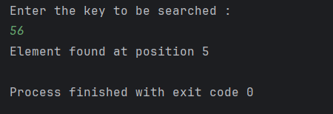

Bubble sort –
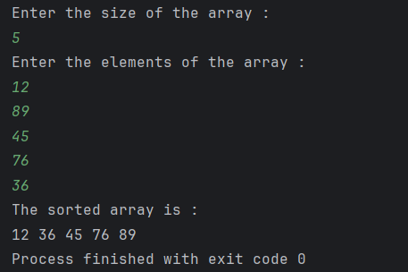
Insertion sort –
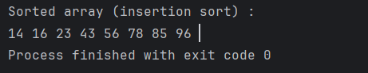

Department of Artificial Intelligence and Data Science

Vision of the Department
To be a preferred hub for nurturing computer engineering aspirants through innovative, ethical, value-based technical education, impactful research, and industry collaboration, to become successful professionals contributing for the betterment of society.

Mission of the Department
To nurture computer engineering professionals by offering: Dynamic learning environment that encourages problem-solving using emerging technology, · National Education Policy aligned evidence-based technical education, fostering innovation, research, and industry–institute
collaboration, Holistic, ethical and sustainable development for lifelong success.

Output Analysis | - Linear Search: The output indicates whether the element is present or not. If it is found, the program displays the position (index) of the element; otherwise, it prints “Element not found.”  - Bubble Sort: The output presents the array elements arranged in ascending order after several passes, demonstrating that larger elements gradually move to the end during each pass.  - Insertion Sort: The output shows the array sorted in ascending order, where elements are properly arranged by inserting each element into its correct position step by step.
Link of student Github profile where lab assignment has been uploaded | https://github.com/dishaangalwar84/JavaFSD
Conclusion | Searching and sorting are basic operations in programming. Linear Search is simple to implement and works with any array, but it becomes slower when dealing with large datasets. Binary Search is faster and more efficient; however, it requires the array to be sorted beforehand. Bubble Sort and Insertion Sort are simple sorting methods that are easy to understand and implement for small datasets. However, both algorithms have a worst-case time complexity of O(n²), which makes them less suitable for large data. Overall, Binary Search is commonly preferred for quick searching in sorted arrays, while Insertion Sort often performs better than Bubble Sort for small or nearly sorted datasets.
Plag Report (Similarity index < 12%) | 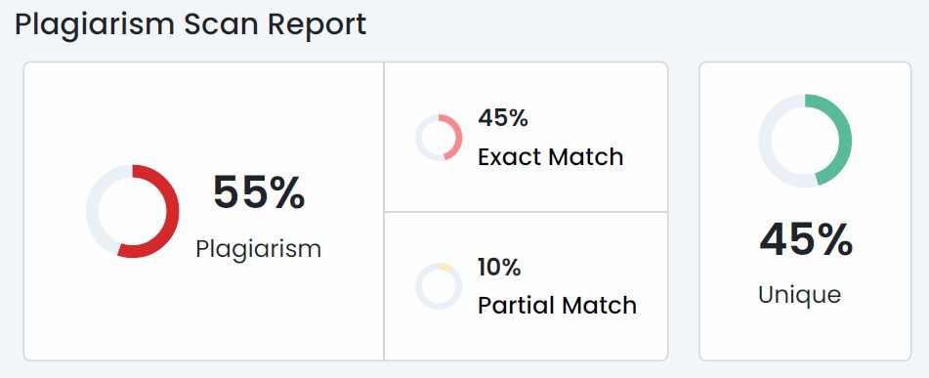
Date | 27/02/2026
Faculty Signed Observation page | 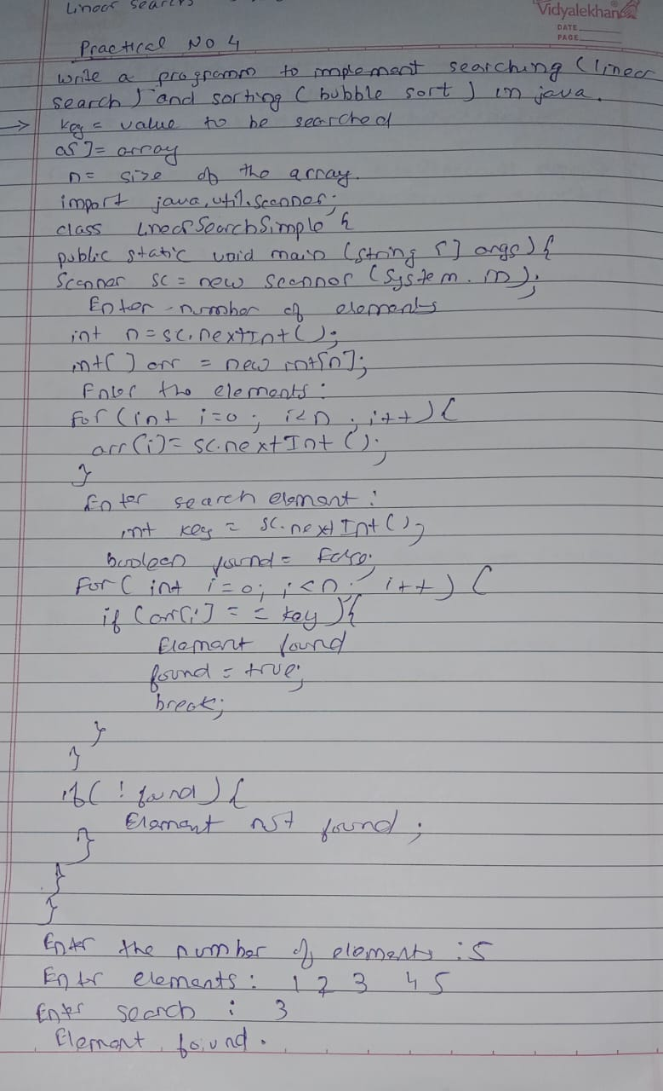

Department of Artificial Intelligence and Data Science

Vision of the Department
To be a preferred hub for nurturing computer engineering aspirants through innovative, ethical, value-based technical education, impactful research, and industry collaboration, to become successful professionals contributing for the betterment of society.

Mission of the Department
To nurture computer engineering professionals by offering: Dynamic learning environment that encourages problem-solving using emerging technology, · National Education Policy aligned evidence-based technical education, fostering innovation, research, and industry–institute
collaboration, Holistic, ethical and sustainable development for lifelong success.

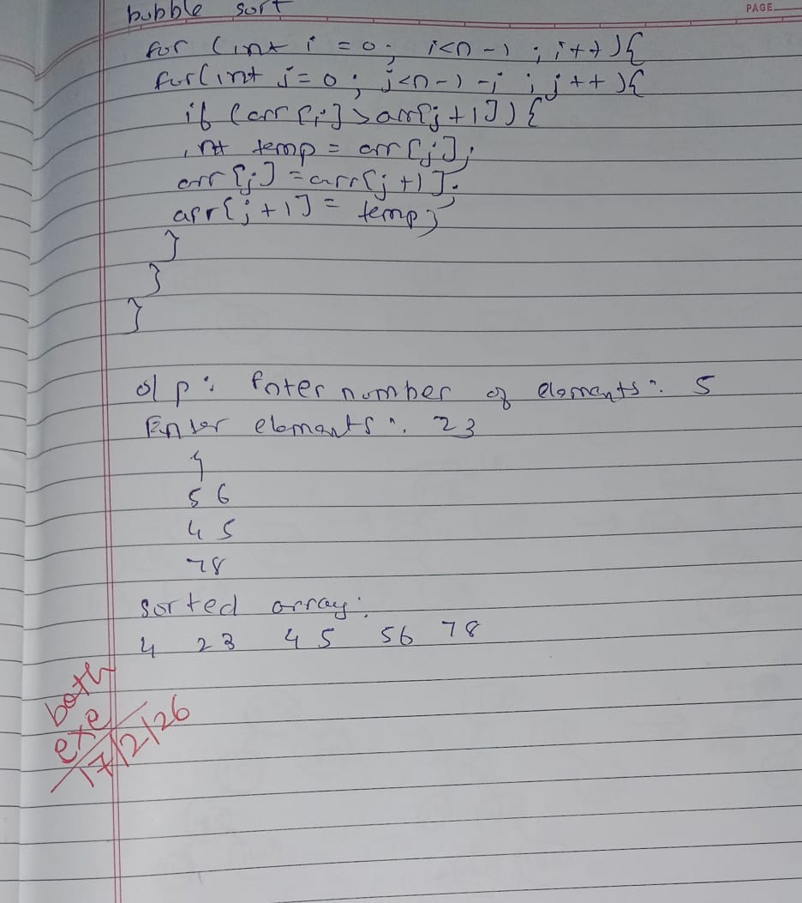

Department of Artificial Intelligence and Data Science

Vision of the Department
To be a preferred hub for nurturing computer engineering aspirants through innovative, ethical, value-based technical education, impactful research, and industry collaboration, to become successful professionals contributing for the betterment of society.

Mission of the Department
To nurture computer engineering professionals by offering: Dynamic learning environment that encourages problem-solving using emerging technology, · National Education Policy aligned evidence-based technical education, fostering innovation, research, and industry–institute
collaboration, Holistic, ethical and sustainable development for lifelong success.

Department of Artificial Intelligence and Data Science

Vision of the Department
To be a preferred hub for nurturing computer engineering aspirants through innovative, ethical, value-based technical education, impactful research, and industry collaboration, to become successful professionals contributing for the betterment of society.

Mission of the Department
To nurture computer engineering professionals by offering: Dynamic learning environment that encourages problem-solving using emerging technology, · National Education Policy aligned evidence-based technical education, fostering innovation, research, and industry–institute
collaboration, Holistic, ethical and sustainable development for lifelong success.

